Project Design Phase Solution Architecture

Date | 9 Feb 2026
Team ID | LTVIP2026TMIDS60231
Project Name | ToyCraft Tales: Tableau's Vision into Toy Manufacturer Data
Maximum Marks | 4 Marks

Solution Architecture:
Solution architecture is a complex process – with many sub-processes – that bridges the gap between business problems and technology solutions. Its goals are to:

- Find the best tech solution to solve existing business problems.
- Describe the structure, characteristics, behavior, and other aspects of the software to project stakeholders.
- Define features, development phases, and solution requirements.
- Provide specifications according to which the solution is defined, managed, and delivered.

Example - Solution Architecture Diagram:

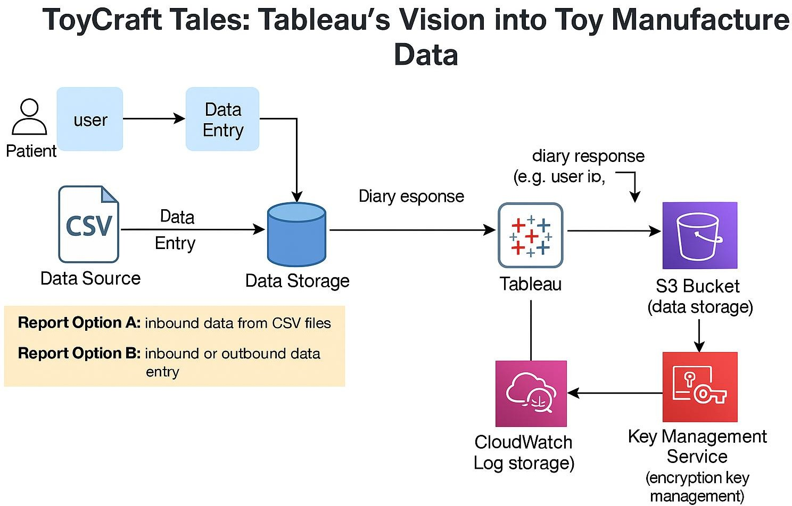

Figure 1: Architecture and Data Flow of the ToyCraft Tales Tableau-Based Analytics System

Reference: https://aws.amazon.com/blogs/industries/voice-applications-in-clinical-research- powered-by-ai-on-aws-part-1-architecture-and-design-considerations/

